**19SSK301 - SOFT SKILLS-II**

**Being Enterprising**

1. **Identify at least one club that you would join in your campus, which could provide you a platform to be more enterprising. Initiate a correspondence with the concerned person who is in charge, to apply for membership at the club. Share a proof of your interaction or eventual result (letter / email / membership badge / Club ID card)**

From,

R.Abhinav

CSE-E(2019-2023)

October 12,2021

To,

Dr. D.Venkataraman

NSS Coordinator, Amrita Vishwa Vidyapeetham

**Subject:** Joining in National Service Scheme

Respected Sir,

I am Abhinav of CSE of 2019-2023 batch bearing roll number CB.EN.U4CSE19453 would like to bring your notice that, I am very much interested in joining our NSS club. There are more ways to learning and tuning me in this group. I can improve my way of helping others and communication with the fellow people and elders as well. I am very much excited to see me in this club.

I will be waiting for your response. Thanking you.

Yours Sincerely

R.Abhinav

1. **Identify a** **productive activity for your department, which you could initiate. Send an email to your class advisor seeking permission to meet and discuss the same. Share the email as well as the experience.**

From:

R.Abhinav

CSE-E

2019-2023

October 12, 2021

To,

Mrs. T.Bagyammal

The Class Advisor

Coimbatore.

**Subject:** Permission for hosting a webinar on Data Science.

Respected Madam,

I am R.Abhinav from CSE-E of batch 2019-2023 bearing roll no. CB.EN.U4CSE19453 would like to bring to your notice that I am very much interested in a hosting a webinar in collaboration with Dphi in our reputed institution.

I am writing this email to you in order to kindly allow me to discuss this with you. So that this can be conducted on the coming days. I ensure, this will not affect any classes and exam as well and I will make sure of hosting this successfully.

I shall be obliged. Waiting for your positive response.

Yours Sincerely,

R.Abhinav

12-10-2021

**Experience:**

If this webinar is conducted sucessfully the participants will gain lot a new points on data science. As the event is conducted and guided by field experts who are having 10 years of work experience in this field. There will be a query clearing time where the participants can clarify their doubts.

1. **Based on the GET2 Test, identify the areas to improve your enterprising quotient. Now, prepare a detailed roadmap to become more enterprising. Once you have finalized it, share the same. Also, review the roadmap with your mentor and seek feedback.**

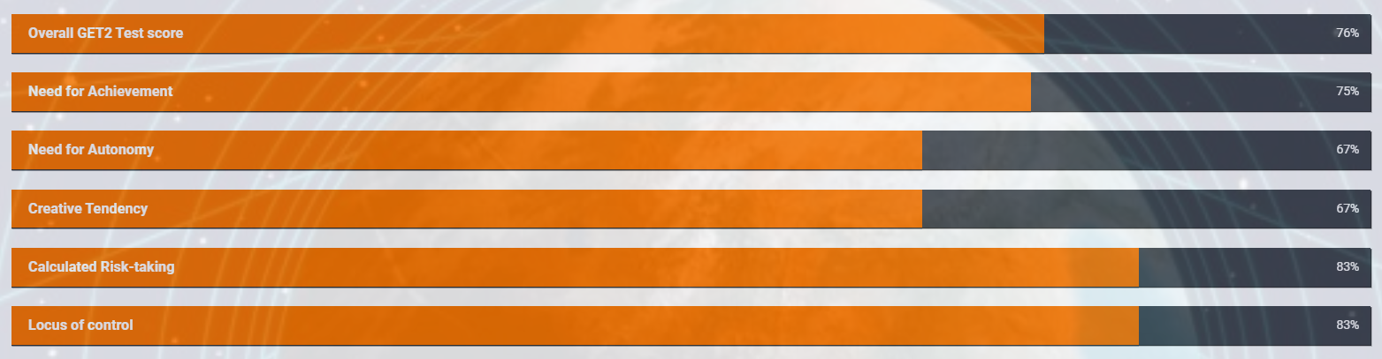

As seen from the test report,

* Overall test score is pretty good which likely shows that am having some contexts and characteristics in enterprising.
* But however there are areas where I need to improve myself.
* The areas that must be improved are **need for autonomy** and **creative tendency**.
* From the Score, it declares that I am somewhat independent. But to become a successful enterpreneur I need to develop more leadership skills. This can be overided by hosting some projects.
* And also from the score, we can see that my creative thinking is not upto the mark.
* To develop my own latent creative skills:

1. Conditions for thinking are in a relaxed space and then use techniques to generate lots of ideas.
2. Should be relaxed and intent of thinking must be improved.